Author Template and Guidlines

for your Manuscript for the

Materials Science and Engineering (MSE) Congress 2026

- Introduction
This author guideline is intended to help you prepare your manuscript for MSE 2026 so that it can be processed in optimal form. To facilitate your work, it is strongly recommended to use this Word template directly for editing the manuscript. This template will be used for printing at original size. If you have any questions, please do not hesitate to contact us. All papers must be written in English and created in Microsoft Word using this template. The paper size is DIN A4. Please use the default margins as specified in the DOCX document. Use Arial font with single line spacing and a font size of 9 pt for the main text, 10 pt for headings and the English title of the contribution, and 12 pt for the main title.

The manuscript must present the objectives and results of the work. The text should be structured as is customary for technical and scientific publications (example: Introduction – Experimental details – Results – Discussion – Summary).

The manuscript for lecture and poster authors should not exceed 6 pages, including figures. Plenary speakers may submit up to 10 pages, including figures.

Final manuscripts must be submitted as a PDF file.

- Layout
  - Template
The text should be subdivided by at most one intermediate subheading. The style templates used are shown in Table 1.
Please ensure that a table is not split by a page break.

Table 1 Format templates in use

Description | Font | Font Size | Style Sheet
Title | Arial, bold, centered | 12 | Title
Author | Arial, centred | 9 | Authors
Abstract/Keywords | Arial, justified text | 8 | Summary
Überschrift 1 | Arial, bold, left-aligned | 10 | Heading 1 current
Überschrift 2 | Arial, bold, left-aligned | 9 | Heading 2 current
Text | Arial, justified text | 9 | Text
Bilder | Arial, bold, left-aligned | 8 | Caption
Tabellen | Arial, bold, left-aligned | 8 | Table
Gleichung | Arial, left-aligned, tab stops | 9 | Equation
Literatur | Arial, justified text | 8 | Literature
Please also note that no text boxes may be created in Word and that paragraph formatting must comply with the specified settings.

  - Figures and Tables
All figures and tables must be placed in the text directly where they are discussed. Each figure must have a figure caption. Each table must have a table heading. Each figure and each table must be mentioned in the text and should be highlighted in bold (Figure 1). In the figure caption and the table heading, the designations should also be in bold. Explanatory text remains in normal 8 pt font.
When presenting figures and diagrams, please ensure that all content is clearly legible.
Please avoid very light colors (e.g., light yellow, light green). Do not use colored text in the body text.
If your manuscript contains graphics and figures, insert them at the appropriate locations in the manuscript. If possible, avoid highly compressed JPEG files, as print quality will suffer.
If you are using scanned photos, please ensure that the digital version of the photo is 1:1 the size required for inclusion in the manuscript. This is because enlarging smaller photos will result in a loss of quality when printed. The scan resolution must be 300 dpi.
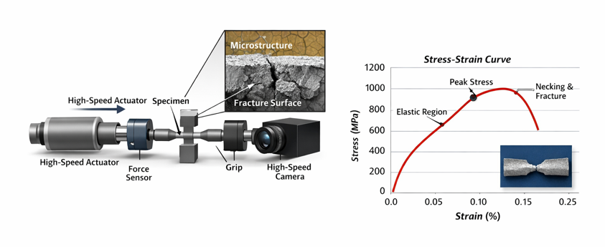
Figure 1: Example of a test setup for carrying out high-speed tensile tests (schematic)
Graphics and figures should be inserted using the option “in line with text” and should not be freely movable on the page. Otherwise, consistent formatting is not possible. The figure caption should have a spacing of 6 pt from the figure. After the figure caption, keep a spacing of 12 pt to the following text.
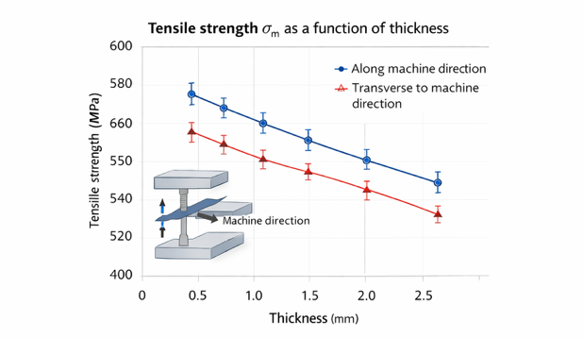
Figure 2: Tensile strength σm as a function of thickness; specimen extraction along and transverse to the machine direction

  - Equations
Equations must be separated from the text. They should be numbered with Arabic numerals. These numbers are placed right-aligned outside next to the equation in parentheses.
(1)

  - Emphasis
You should avoid underlining and bold type in the text for emphasis wherever possible. Colored emphasis in running text is not permitted.

  - Quantities and Units
Units must be given in SI units. Nomenclature and abbreviations should comply with applicable standards and rules.

  - References
References should be listed in summary form and numbered consecutively at the end of the paper. References in the text should be indicated in square brackets [1].

- Submission of manuscripts
Manuscripts should be submitted via the
Manuscript submission and management link.

Submission deadline: September 01, 2026
Please note that submissions are not subject to a review process.

- Conclusions and outlook
Acknowledgements – This section can be used to acknowledge funding institutions or individuals, companies, and organizations that have contributed to the work.

References
[1] J. Haenel, J. Kina, P. Schaumann: Zur Erweiterung des Anwendungsbereiches von Stahlträgerverbundkonstruktionen. Stahlbau 63/3 (1994), S. 279–283
[2] J. K. Sahu, U. Krupp, H.-J. Christ: Fatigue: Crack initiation behaviour in embrittled austenitic-ferritic stainless steel. Journal of Fatigue 45 (2012), S. 8–14
[3] O. Buxbaum: Betriebsfestigkeit – Sichere und wirtschaftliche Bemessung schwingbruchgefährdeter Bauteile, Verlag Stahleisen, Düsseldorf, 1992 (2. Auflage)
[4] M. Merklein, C. Hezler, C. Kopp, J. Hecht, L. Schaller: Kennwertermittlung für Streck-Biege-Beanspruchungen. In: Pohl, M. (Hrsg.): Konstruktion, Qualitätssicherung und Schadensanalyse, Tagungsband Werkstoffprüfung 2010, Verlag Stahleisen, Düsseldorf, 2010, S. 253–258
[5] Rutherford Lexikon der Elemente, http://www.uniterra.de/rutherford/_pseasw.htm, recherchiert am 31.01.2013
Example: [1] and [2] magazine article; [3] book; [4] Contribution from conference proceedings; [5] web address

